Repository: MSOE-CPE2600/signals-turney-benjankowski: msoe-cpe2600-classroom-cpe2600-2025-signals-turney-signal created by GitHub Classroom
signal_segfault.c
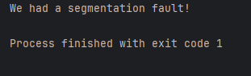

signal_handler.c
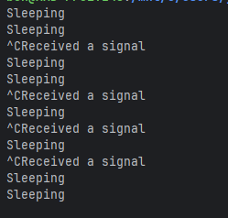

signal_alarm.c
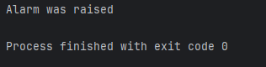

signal_sigaction.c
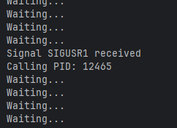

Send and receive random value
